NAME: **Ibrar Babar**

Roll No: 19P-0104

Section Lab :: (**2B2**)

Subject: DLD

Lab Task: [Seven Segment Display]

**{Sir Yousuf}**

**Logic diagram**

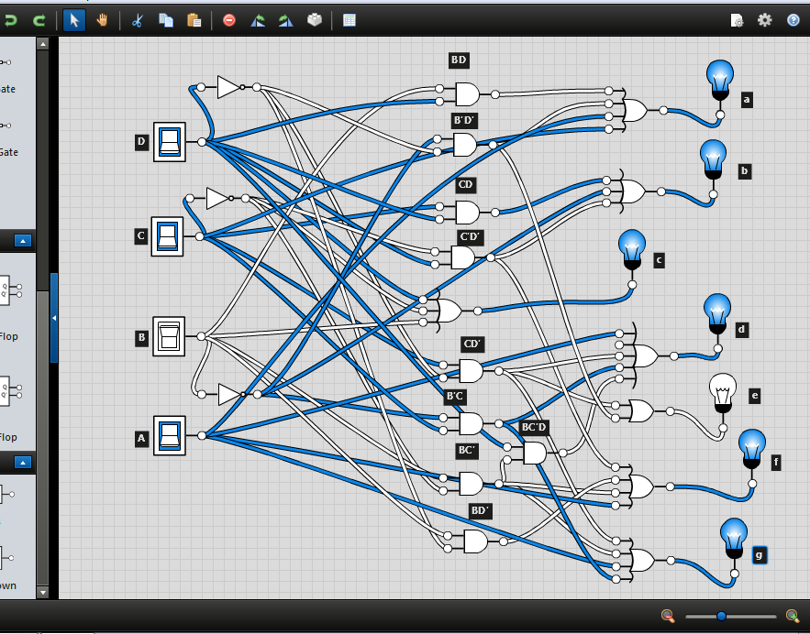

**Truth Table** for each digit from 0 to 9.

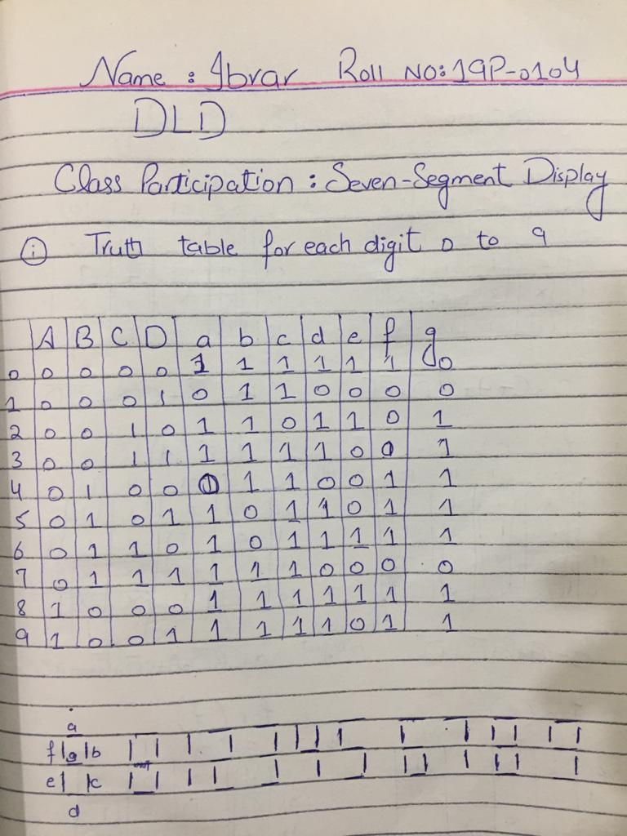

**Karnaugh map** for from 0 to 9.

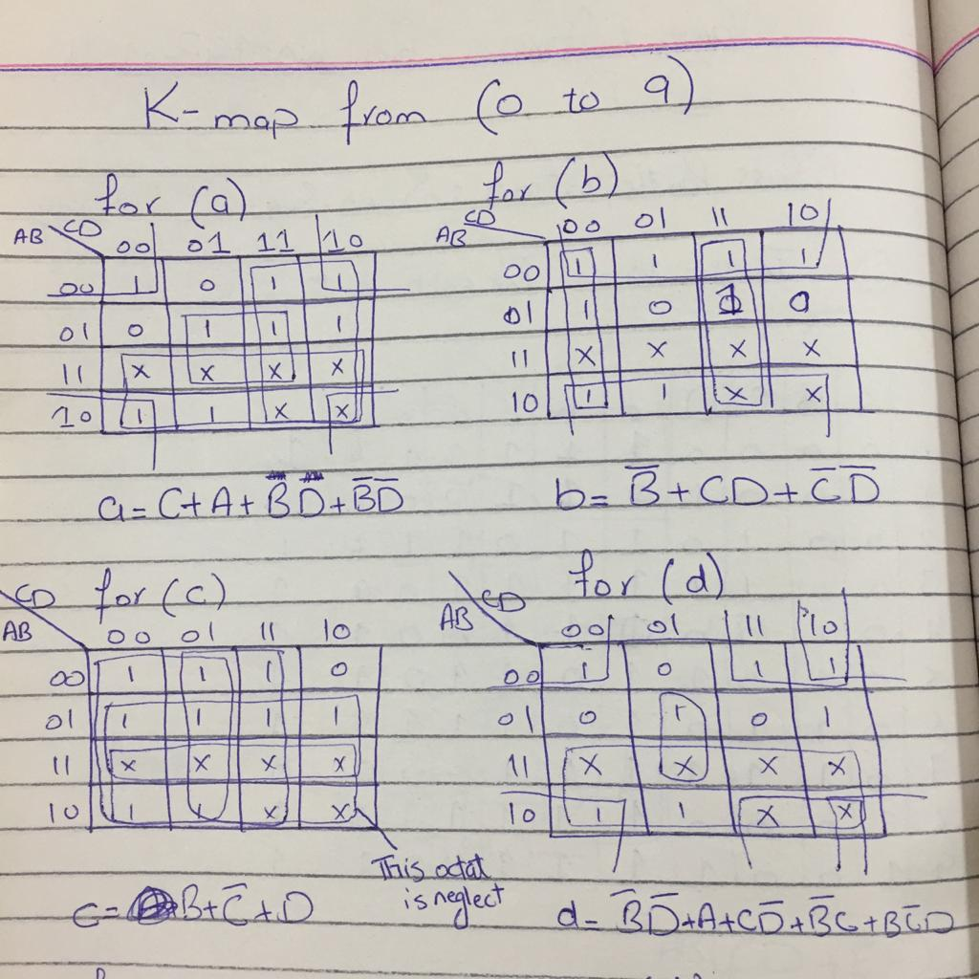

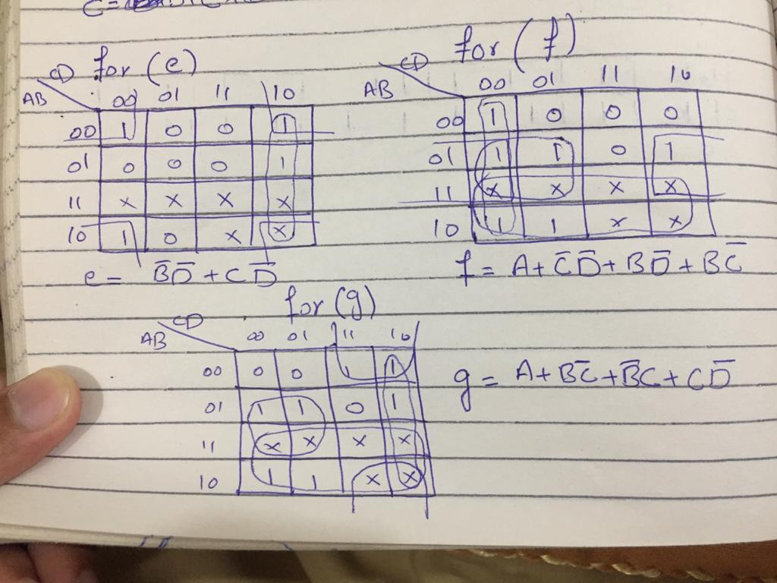

**Logic Circuit** to show (light up) appropriate segment for 0 to 9 digits.

